**College Network Topology Project**

**BY : ARUN R G**

**EMAIL :** [**2k20cse006@kiot.ac.in**](mailto:2k20cse006@kiot.ac.in)

**DATE : 04/07/2022**

College Network Topology Project

**Tech Used :**

* Cisco Packet Tracer 8.1
* Packet Tracer's Built-In Simulation mode for packet sniffing

**Devices Used :**

* Personal Computers [PC-PT] : 6
* Network Switches [2960-24TT] : 3
* Routers :
* Wired Router [2911]
* Wireless Router [WRT300N]
* Smartphones [SMARTPHONE-PT] : 2
* Laptop [Laptop-PT] : 1
* Servers :
* DHCP Server [Server-PT]
* DNS Server [Server-PT]

**Logical Spaces :**

* **CCs [ Computer Centre ]**
* **CC01**
* **CC02**
* **Admin Cabin**
* **KIOT Corridor**

**Device Information Table :**

| **Device Name** | **IPV4 Configuration** | | **Default Gateway** | **DNS Server** |
| --- | --- | --- | --- | --- |
| **Type** | **Address** |
| CC01 | Static | 192.168.1.1 | 192.168.1.1 | 192.168.0.5 |
| CC01-01:03 | DHCP | 192.168.1.2 :  192.168.1.256 |
| CC02 | Static | 192.168.2.1 | 192.168.2.1 | 192.168.0.5 |
| CC02-01:03 | DHCP | 192.168.2.2 : 192.168.2.256 |
| ADMIN | Static | 192.168.0.1 | 192.168.0.1 | 192.168.0.5 |
| DHCP Server | 192.168.0.2 |
| DNS Server | 192.168.0.5 |
| KIOT-WIFI | DHCP | 192.168.0.2 : 192.168.0.256 | 192.168.1.1 | 192.165.0.5 |
| Smartphone01 | DHCP | 192.168.15.2:  192.168.15.256 | 192.168.15.1 |
| Smartphone02 |
| Laptop01 |

**DNS Server :**

**DNS Resolve List :**

**impresrep.com -> 192.168.0.5**

**NETWORK TOPOLOGY :**

**Logical :**

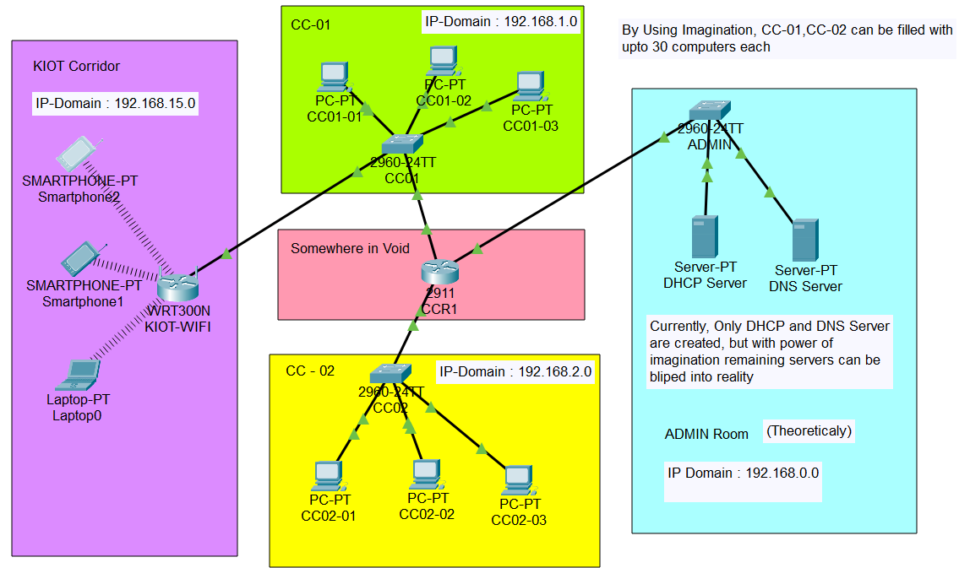

**Physical :**

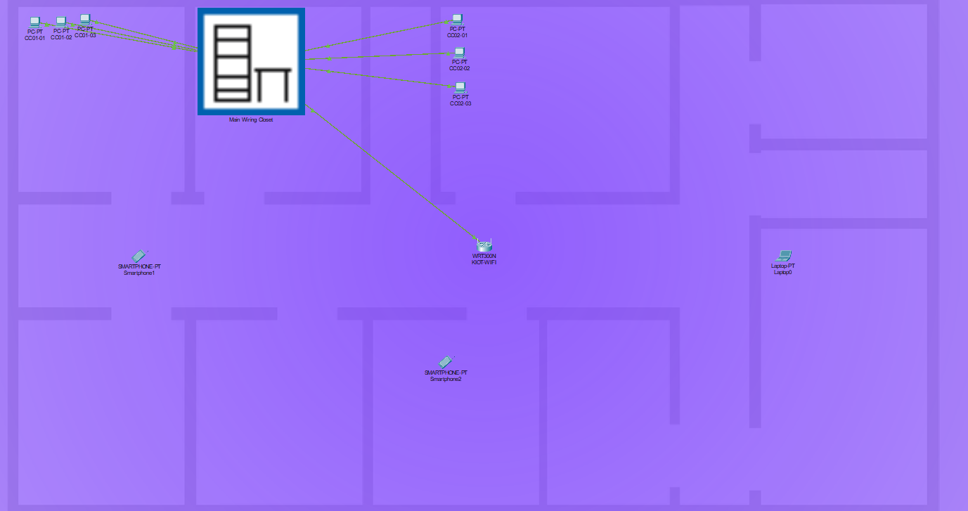

**Packet Flow Chart :**

**Packet flow from Smartphone01 to DNS Server**

